**Abstract**

Following Huang and Pearce (2013), I propose to re-examine the relationship between vocational interests and income using new data from the Occupational Information Network (ONET) and the Bureau of Labor Statistics (BLS). Replicating their design, I aim to observe whether their obtained effect sizes remain consistent with a recently released, larger dataset containing occupation-level interests scores and income. Next, using 20 years of archival data gathered over 30 waves of data collection from the ONET and BLS, I seek to expand on their findings in two ways: a) by examining whether the vocational interest – income relationship varies within and across different occupational clusters and career pathways and b) by examining whether the vocational interest – income relationship has remained stable over time. I will conclude this study by discussing the implications of these findings within the context of career guidance, occupational choice, and the changing nature of the workplace.

**Introduction**

Vocational interests are an individual’s preferences for specific work activities (Low, Yoon, Roberts, & Rounds, 2005). Holland’s RIASEC Model (1973) has become the predominant framework for understanding occupational choice and career decision making across a number of fields, such as counselling psychology, educational psychology, and industrial-organizational psychology (Tracey & Rounds, 1995). This model decomposes the activities someone in the workplace might accomplish into six distinct categories: Realistic (e.g. building a house, working outside), Investigative (e.g. Researching a problem, analyzing data), Artistic (e.g. Graphic design), Social (e.g. Teaching or providing a service to others), Enterprising (e.g. Selling a good), and Conventional (e.g. Operating a cash register).

These six dimensions are traditionally represented as a hexagon that lies within two orthogonal dimensions, People-Things and Data-Ideas (Rounds & Tracey, 1993). Citing Holland, Huang and Pearce (2013, hereafter HP2013) note, “people with certain levels of these interests tend to seek out work environments with parallel tasks and requirements” (pg. 316). Specifically, when an individual’s preferences align with their work environment, there is a higher likelihood for positive outcomes for both the individual and their organization (Edwards & Shipp, 2007).

Research in the aforementioned subfields of psychology has found robust relationships linking vocational interests with a variety of individual work (Nye, Su, & Rounds, 2012), health (Furnham & Schaeffer, 1984), and life (Stoll, Rieger, Ludtke, Nagengast, Trautwein, & Roberts, 2012) outcomes. For example, recent meta-analytic evidence (Nye, Su, Rounds, & Drasgow, 2012; Van Iddekinge, Roth, Putka, & Lanivich, 2011) suggests that vocational interest congruence (i.e. a job’s activities align with a worker’s interests, see Figure 1) can predict job performance, organizational commitment, and job satisfaction above and beyond general mental ability (GMA) and personality.

As mentioned previously, Holland’s RIASEC model serves the purpose of describing both the work preferences of individuals as well as the typical tasks of a given occupation. In the case of the former, vocational interests represent an individual difference that provides organizations with information that can be utilized by a selection system to make inter-individual comparisons (e.g. Someone who is more enterprising or social might be more qualified for a sales position compared to someone who is more investigative or realistic) or for occupational recommendations.

Vocational interests can additionally be used to make inter-*occupational* comparisons. In this case, the vocational interest profile for a given occupation would represent the typical characteristics of that occupation’s work environment (Woods & Hampson, 2010). Building off of my previous example, a sales or marketing position might have a vocational interest profile high on Social or Enterprising interests due to the tasks one would have to accomplish in this role (e.g. Making cold calls, talking to clients, public speaking).

HP2013 note that understanding the relationship between an occupation’s work environment and occupational outcomes is important because it “affords individuals additional considerations for career decision and development, but also provides key information for job seekers” when entering the labor market (HP2013, pg. 315). They additionally note that examining the income-interest relationship is particularly important given income “represents the value and importance that organizations and society as a whole attach to employee productivity and performance” (Abowd, Kramarz, & Margolis, 1999; Smeeding, 1983).

The vocational interest-income relationship was first assessed by Reardon, Bullock, and Meyer (2007) who examined the relationship between interests and income using fives waves of data collected from the United States Census Bureau (1960, 1970, 1980, 1990, and 2000). For their analyses, occupations were classified based on their highest RIASEC profile dimension. Their results indicated that Investigative work was the most highest paid, followed by Conventional, Artistic, Social, Realistic, and Enterprising. However, as noted by HP2013, “no inferential statistical test was conducted to discern the difference across types of occupations” (pg. 316). Further, ignoring all other RIASEC components of an occupation beyond the highest one results in lost information that could provide a more nuanced understanding of this relationship.

Motivated in part by the important roles vocational interests and income play during the occupational decision-making process (CITE) as well as the gaps in the work by Reardon, Bullock, and Meyer (2007), HP2013 set out to use data from ONET and BLS to test a variety of hypotheses and research questions related to the vocational interest-income relationship. In the interest of brevity, their hypotheses and research questions are summarized in Tables 1 and 2, respectively.

Table 1. Hypotheses examined in Huang and Pearce (2013)

|  |  |  |  |
| --- | --- | --- | --- |
| *Hypothesis* | *Supporting Evidence* | *Method* | *Result* |
| **Hypothesis 1.**  Investigative interests will be *positively* associated with annual income at the occupation level. |  | Zero-order correlation | **Supported.**  r = .62  p < .001 |
| **Hypothesis 2.**  Enterprising interests will be *positively* associated with annual income at the occupation level. | Barrick et al., (2003); Chan, Rounds, & Drasgow (2000); Hill & Hansen (1986); Schmitt-Rodermund (2004); Sedge (1985) | Zero-order correlation | **Supported.**  r = .14  p < .001 |
| **Hypothesis 3a.**  Realistic interests will be *negatively* associated with annual income at the occupation level. | Acemoglu & Autor (2011); Autor et al. (2003) | Zero-order correlation | **Supported.**  r = − .35  p < .001 |
| **Hypothesis 3b.** Conventional interests will be *negatively* associated with annual income at the occupation level. | CITATION | Zero-order correlation | **Supported.**  r = −.10  p < .01 |
| **Hypothesis 4.**  Interest levels would better predict annual income in differentiated rather than undifferentiated occupations. | CITATION | Zero-order correlation | **Supported.**  ΔR2 = .04  p < .001 |

|  |  |  |  |
| --- | --- | --- | --- |
| *Research Question* | *Supporting Evidence* | *Method* | *Result* |
| **Research Question 1a.**  What are the associations between social interests with annual income at the occupation level? | CITATION | Zero-order correlation | r = .36  p < .001 |
| **Research Question 1b.**  What are the associations between artistic interests with annual income at the occupation level? | CITATION | Zero-order correlation | r = .26  p < .001 |
| **Research Question 2a.**  What are the simultaneous effects of RIASEC interests in predicting annual income at the occupation level? | CITATION | Hierarchal Multiple Regression | - |
| **Research Question 2b.**  What are the relative importance of RIASEC interests in predicting annual income at the occupation level? | CITATION | Relative Weights Analysis (RWA) | - |
| **Research Question 3.**  Does education and training requirement mediate relationships between interest profile characteristics and annual income? | CITATION | Mediation Analysis | - |

In summary, HP2013 find that occupation-level vocational interests aredifferentially predictive of income. For example, the more investigative an occupation’s work environment is (i.e. Occupations that regularly make use of research and critical thinking tasks), the higher the reported occupation’s median income was (*r* = 0.62, *p* < 0.01). This is consistent with prior work that has found investigative interests are positively correlated with cognitive ability (Ackerman & Heggestad, 1997) and are reflecting of a shift towards an information-driven economy (Castells, 2000). In addition, HP2013 find that Realistic interests (i.e. work environments that require manual labor) were the RIASEC dimension most negatively correlated with income (*r* = 0.-35, *p* < 0.01). Such a finding is consistent with their hypotheses as well as previous work by Acemoglu and Autor (2011) who note that realistic occupations are ones with limited room for autonomy and have tasks most likely to be automated. One additional finding to note is that occupations with differentiated work environments (i.e. occupations with higher variability across the six RIASEC dimensions) had higher levels of reported median income than undifferentiated occupations.

One aspect of HP2013 worth noting is their use of the ONET 16.0 Database. This is important to address for two reasons: First, the ONET 16.0 Database is one of thirty-seven waves of data collected and made publically available by ONET. Second, eight additional waves of data have been released by ONET since the HP2013 study was published. As a result, there are new data with the potential to reshape our understanding of the income – interest relationship.

Understanding how income and interests are related to each other is crucial to both researchers and practitioners for a variety of reasons. For organizational practitioners, having an explicit understanding of how workplace environments are differentially valued can ensure employee compensation is fair (Bloom, 2004). For individuals entering the labor market, beit for the first time or switching careers, understanding the relationship between interests and income can afford them more information when choosing a career (Ginzberg, 1972). Further, given the availability of these longitudinal data, incorporating all waves of data collection can inform the field of how occupational interests profiles, and their relationship with income, have been valued by the labor market over time and how such changes coincide with the workplace has been changing (Wegman, Hoffman, Carter, Twenge, & Guenole, 2018). More broadly, revisiting this topic and replicating prior work in this domain is important to ensure vocational and organizational researchers develop new knowledge that is based on a sound foundation (Tsang & Kwam, 1999).

Thus, the goal of this research project is three-fold: First, I seek to use the recently released ONET 23.2 Database to replicate the design and analyses from HP2013 with the goal of examining the extent to which HP2013’s original findings regarding the interests-income relationship hold with a larger sample of observations.

**RQ1: Which of HP2013’s findings will replicate with new data?**

The second goal of this study is to expand on the HP2013’s design by examining a) how the interests-income relationship varies within and between different groups or clusters of occupations and b) how the interests-income relationship has varied over time. ONET’s occupation data is hierarchically structured such that a given occupation is simultaneously nested within both a career cluster and occupational pathway (in-progress diagrams are at the end of this draft). *Career clusters* contain occupations in the same field of work that require similar skills. Students, parents, and educators, and individuals re-entering the labor market can use Career Clusters to help focus education plans towards obtaining the necessary knowledge, competencies, and training for success in a particular career pathway (CITE). *Occupational pathways* are small groups of occupations within a career cluster that, in addition to requiring similar skills, have similar knowledge and interests requirements (CITE).

**RQ2a: How does the interest-income relationship vary across occupational clusters and career pathways?**

It’s been repeatedly in both empirical research and the popular press that individual workplaces, and the labor market as a whole, are dynamic systems that are constantly undergoing change. For example, Wegman and colleagues (Wegmen, Hoffman, Carter, Twenge, Guenole, 2016) conduct a cross-temporal meta-analysis on the core components of the Job Characteristics Model (Heckman and Oldham, 1977) and observe that US workers perceive greater levels of interdependence, skill variety, and autonomy in work over a forty-year time period.

In addition to *perceptions* of work changing, labor economic research has observed changes in labor market polarization with respect to the types of jobs individuals hold. The Skill-Based Technological Change hypothesis (Katz & Autor, 1999; Goldin & Katz, 2009; Acemoglu & Autor, 2011) states that rising demand for highly educated workers alongside technological change and automation have led to job opportunities being concentrated in relatively high-skill, high-wage jobs and low-skill, low-wage jobs. Given high-skill jobs map onto Investigative interests and low-skill jobs map onto Conventional and Realistic interests (cite?), we would expect that these different RIASEC dimensions have been differentially valued by the labor market over time, in accordance with job polarization.

**RQ2b: How has the interest-income relationship changed over time?**

**RQ2c: How has the interest-income relationship changed over time within and between occupational clusters?**

In the next section, I provide an overview of ONET’s data archive including the most recent release (23.2) as well as the data used in HP2013’s analyses. I then move on to specifying the models I intend to implement for replicating HP2013 (RQ1) as well as the new research questions this study will address (RQ2a, RQ2b). Specifically, I make use of various of two- and three-level mixed effects models to account for the homogeneity of interests across both occupational clusters and overtime. I conclude this proposal with a discussion of the potential implications of this study within the context of occupational choice and the changing nature of work as well as fruitful future areas of research.

**Method**

Sample

The data for this proposed study comes from the ONET 23.2 release. Beginning in 1998, ONET has released detailed information regarding the knowledge, skills, abilities, work context, work values, interests, and tools for a large sample of occupations on a yearly basis. HP2013 used a sample of 665 occupations in their initial study of the income-interests relationship. To address **RQ1**, I will revisit their design and hypotheses with a larger sample of interest data spanning 973 occupations. To address **RQ2a, RQ2b,** and **RQ2c**, I will use all 37 waves of publically available ONET interests data covering an approximately 20 year time period. Income data will provided by the Bureau of Labor Statistics’ (BLS) data archive. BLS has publically available income and employment data at the occupation-level covering every year since 1988.

Procedure

Using ONET SOC codes, I plan to link these two data sources together to create a unified dataset containing vocational interest values and income for every occupation over this 20-year time period. Table XXX below shows which ONET data release coincides with BLS data based on the released month and year. Using the same filtering criteria as HP2013, occupations that do not have income data will be removed from the analysis.

[Put table here for showing where income data maps onto interests data in terms of release date / whatever.]

Measures

**Interests**

RIASEC scores obtained from subject matter experts who are tasked with rating the extent to which certain statements describe an occupation’s work environment (Rounds, Smith, Hubert, Lewis, and Rivkin, 1999). Such ratings are on a seven-point scale, where 1 is labeled as “not at all characteristic”, 4 is labeled as “moderately characteristic”, and 7 is labeled as “completely characteristic”.

**Differentiation**

Following HP2013, I will assess interest differentiation by computing the standard deviation of all six interests scores for each occupation in the sample.

**Annual Income**

Following HP2013, I will use income data from the BLS OES data as my outcome variable. Further, I will apply a log-transformation to account for any distributional skew and the effect of outliers.

**Education / Training**

Following HP2013, I will use job zone data from ONET to represent the amount of education and training typically required for each occupation. Job zone scores range from “1” to “5,” with a job zone of “1” indicating an occupation that requires little or no preparation and a job zone of “5” indicating an occupation that requires extensive preparation.

Proposed Data Analysis

**RQ1** (Based on HP2013)

Model 1:

[](https://www.codecogs.com/eqnedit.php?latex=%5Clog(Income_j)%20%3D%20%5Cbeta_0%20%2B%20%5Cbeta_1%20Realistic_j%20%2B%20%20%5Cbeta_2%20Investigative_j%20%2B%20%20%5Cbeta_3%20Artistic_j%20%2B%20%20%5Cbeta_4%20Social_j%20%2B%20%20%5Cbeta_5%20Enterprising_j%20%2B%20%5Cbeta_6%20Conventional_j%20%2B%20%5Cepsilon_j%0)

where

[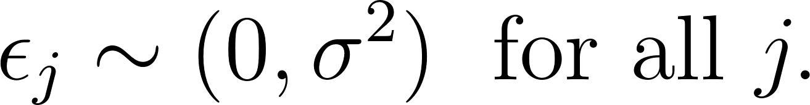](https://www.codecogs.com/eqnedit.php?latex=%5Cepsilon_j%20%5Csim%20%5CN(0%2C%5Csigma%5E2)%20%5Chspace%7B0.1in%7D%20%5Cmbox%7Bfor%20all%20%7D%20j.%0)

Model 2:

[](https://www.codecogs.com/eqnedit.php?latex=%5Clog(Income_j)%20%3D%20%5Cbeta_0%20%2B%20%5Cbeta_1%20Realistic_j%20%2B%20%20%5Cbeta_2%20Investigative_j%20%2B%20%20%5Cbeta_3%20Artistic_j%20%2B%20%20%5Cbeta_4%20Social_j%20%2B%20%20%5Cbeta_5%20Enterprising_j%20%2B%20%5Cbeta_6%20Conventional_j%20%2B%20%5Cbeta_7%20Differentiation_j%20%2B%20%5Cepsilon_j%0)

where

[](https://www.codecogs.com/eqnedit.php?latex=%5Cepsilon_j%20%5Csim%20%5CN(0%2C%5Csigma%5E2)%20%5Chspace%7B0.1in%7D%20%5Cmbox%7Bfor%20all%20%7D%20j.%0)

Model 3:

[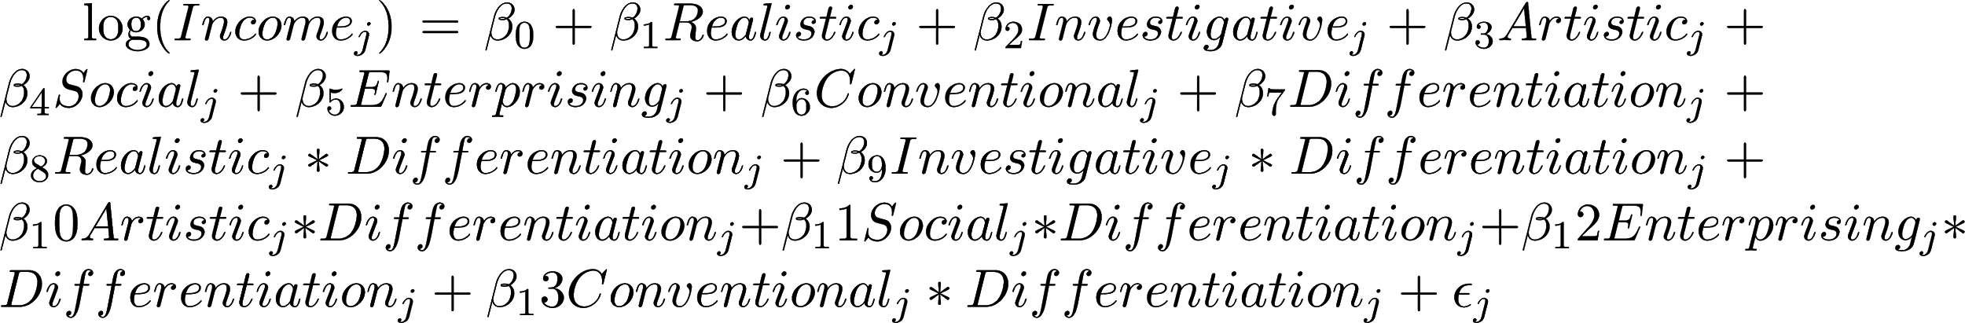](https://www.codecogs.com/eqnedit.php?latex=%5Clog(Income_j)%20%3D%20%5Cbeta_0%20%2B%20%5Cbeta_1%20Realistic_j%20%2B%20%20%5Cbeta_2%20Investigative_j%20%2B%20%20%5Cbeta_3%20Artistic_j%20%2B%20%20%5Cbeta_4%20Social_j%20%2B%20%20%5Cbeta_5%20Enterprising_j%20%2B%20%5Cbeta_6%20Conventional_j%20%2B%20%5Cbeta_7%20Differentiation_j%20%2B%20%5Cbeta_8%20Realistic_j*Differentiation_j%20%2B%20%5Cbeta_9%20Investigative_j*Differentiation_j%20%2B%20%5Cbeta_10%20Artistic_j*Differentiation_j%20%2B%20%5Cbeta_11%20Social_j*Differentiation_j%20%2B%20%5Cbeta_12%20Enterprising_j*Differentiation_j%20%2B%20%5Cbeta_13%20Conventional_j*Differentiation_j%20%2B%20%5Cepsilon_j%0)

where

[](https://www.codecogs.com/eqnedit.php?latex=%5Cepsilon_j%20%5Csim%20%5CN(0%2C%5Csigma%5E2)%20%5Chspace%7B0.1in%7D%20%5Cmbox%7Bfor%20all%20%7D%20j.%0)

RQ2a: 2-level Multilevel model

Mixed effects model

Level 1

$log(Income)_{ij} = β_{0j} + β_{1j}X_{ij}+ ϵ_{ij}$

Level 2

$β_{0j}=γ_{00}+ U_{0j}$

$β_{1j}=γ_{10}+U_{1j}$

RQ2b: 2-level Multilevel Model (over time)

Mixed effects model

Level 1

$log(Income)_{ij} = β_{0j} + β_{1j}X_{ij}+ ϵ_{ij}$

Level 2

$β_{0j}=γ_{00}+ U_{0j}$

$β_{1j}=γ_{10}+U_{1j}$

: 3-level Multilevel model

**Discussion**

Research across a number of social scientific fields has provided evidence that the workplace has been changing and will continue to change due to macro and micro-level phenomena. Given the rise of automation, new technologies, and new industries, different components of the work environments have the potential to be differentially valued in the labor market. Following from this, the extent to which an occupation is valued in the labor market has the potential to influence education people obtain and the careers they pursue.

Huang and Pearce (2013) lay the foundation for examining these topics by observing the extent to which occupation-level vocational interests (i.e. characteristics of the work environment) are predictive of income. They find, in general, that interests differentially predict income and that investigative interests are the most predictive of income when aggregating over all occupations and career clusters.

In the present study proposal, I plan replicate their original study to examine if their results are consistent with new data from O*NET. Further, I plan to expand on their findings in a number of ways. First, I propose to examine how the interests-income relationship varies among the occupational clusters ONET uses to group the occupations they collect data on. Next, I propose to use longitudinal data to examine the extent to which the interest-income relationship has fluctuated or remained consistent over a 20-year time period. Finally, I combine these two research questions to examine the temporality of the interests-income relationship amongst these career clusters.

Some potential limitations to this study include the unit of analysis that I intend to use as well as the nature of the longitudinal data that ONET and BLS provide. Both governmental agencies provide data at the *occupation*-level. Thus, this proposal is unable to examine how an *individual’s* vocational interests may be related to their income or, more broadly, how interests within-individuals change over time. The lack of intensive, longitudinal within-person data examining vocational interests is a lacuna that has been acknowledged by previous interests researchers for several years now (CITE). Understanding how interests dynamically unfold over time, and how such dynamics relate to individual work and life outcomes, could be a fruitful area of future research.

One additional avenue for future exploration by vocational scholars is examining the effect of local labor markets (LLM) on income and interests. LLM often play a pivotal role in individual income (CITE). For example, a software developer in Nebraska might have a drastically different income ($$$) compared to someone in the same position located in Silicon Valley ($$$). Thus, I would encourage future research examining vocational interests and income to incorporate both spatial data and data at the individual-level. Some potentially interesting question in this domain might include: *How do vocational interests spatially differ in the United States? Do changes in vocational interests predict change in geographic mobility?*

One additional limitation of the proposed study is it’s exclusive focus on United States data. Previous research has noted that there exist cross-cultural differences in vocational interest (Fouad, 2002). Thus, there is reason to believe that certain occupation-level interests may be differentially valued across different countries. Some potential research questions to tackle this limitation would be: *How does the vocational interest - income relationship differ across countries?*

One final limitation of this proposal worth addressing is how information is updated in the ONET and BLS data. Interest data at the occupation-level that remain consistent over waves of ONET data releases may reflect stability in the interests of that occupation or that no new data was collected for that occupation, despite the potential for changes to have taken place. These different data generating processes should be acknowledged and future research should take care to determine which of these is reflective in the data researchers collect.

References

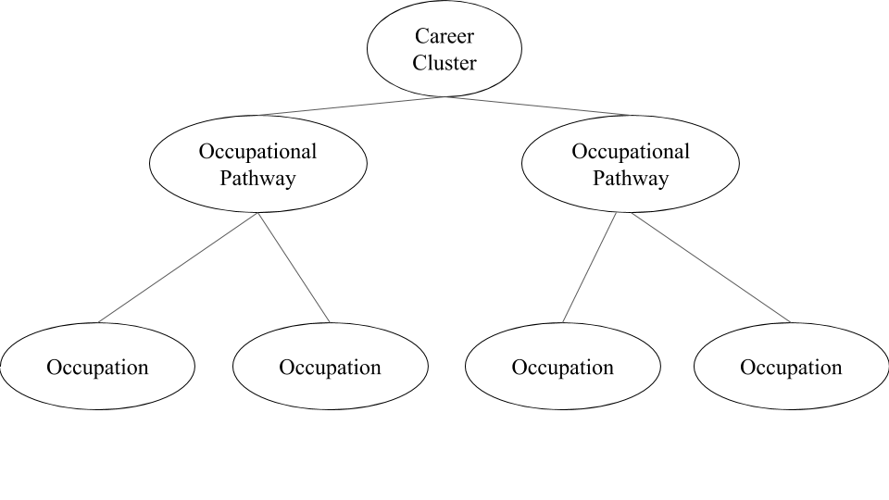**Figure X**. Hierarchical structure of ONET occupational data.

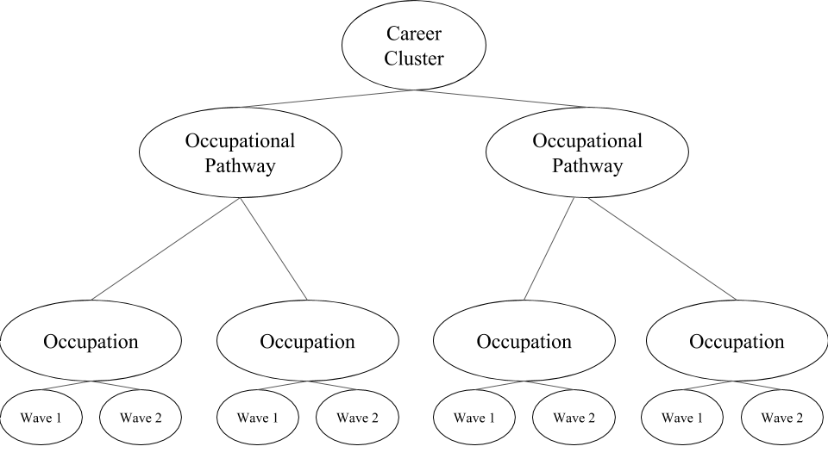

**Figure X**. Hierarchical structure of ONET occupational data including time varying component. Note that the number of time points has been truncated to two due to space constraints.